1. METAL CASTING
CASTING: Casting is a process in which the liquid molten metal is poured in to casting cavity whose shape is same as that of casting to be produced, allow it to solidify and after solidification the casting will be taken out by breaking the mould. |  | 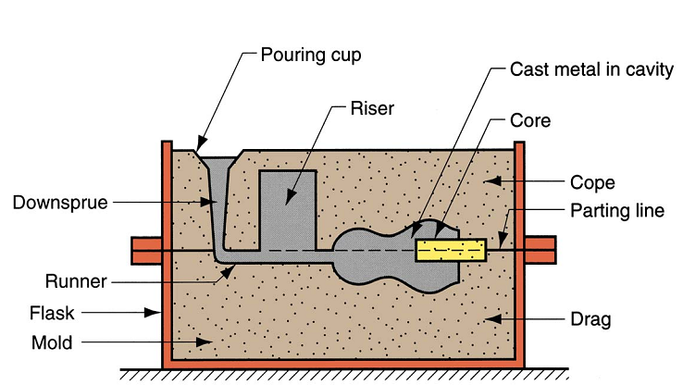
STEPS IN CASTING PROCESS:  - Pattern making  - Mould and core making  - Pouring and solidification  - Fettling  - Inspection | ADDITIONAL TOPICS:  - Riser Design  - Special Casting Process  - Defects
PATTERN MAKING
Pattern is the replica of the casting to be produced. Replica means the shape of the pattern remains same as the shape of casting to be produced, but the size and material will be different.
$$Pattern Size=Casting Size±Allowances$$
ALLOWANCES
MAJOR ALLOWANCES | MINOR ALLOWANCES
- Shrinkage Allowances  - Machining Allowances | - Draft Allowances  - Shake Allowances  - Distortion Allowances

- SHRINKAGE ALLOWANCES:  $$Pouring Temp. \left(P.T.\right)=Melting Temp.+ Degree of Superheat (150 to 200 °C)$$  E.g. P.T. of Fe = 1700$°C$ And Al = 800$°C$ but melting temp are respectively ($1539°C$ and 660$°C$)  STAGES OF COOLING:  $$P.T.\left(L\right)\underset{→}{Cool \left(S.H.\right)}Freezing Temp.\left(L\right)\underset{→}{Cool \left(L.H.\right)}$$  $$Freezing Temp.\left(S\right)\underset{→}{Cool \left(S.H.\right)}Room Temp(S)$$ | 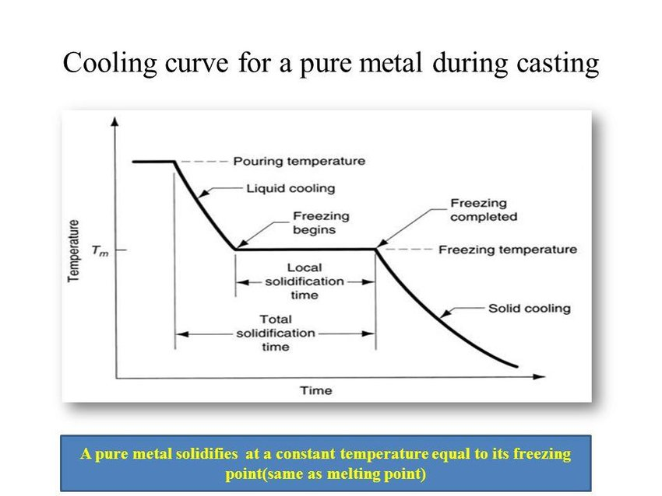
LIQUID SHRINKAGE: Because the liquid is always measured in terms of volume. Hence, the liquid shrinkage is always specified as a percentage over volume.
- Out of all the metals undergoing the casting process, Aluminium has largest shrinkage in the liquid state, nearly about 7%.
- Liquid Shrinkages takes place in the casting process are compensated by providing riser in the process.
SOLID SHRINKAGE: Solids are always measured in terms of dimensions therefore the solid shrinkage is always specified as percentage over dimension.
- Brass has a highest value of coefficient of thermal expansion hence, it’s shrinking largest.  - The total shrinkage i.e. (Liquid + Solid) Shrinkage is highest in the steel.  - Solid Shrinkage taking place in the casting process can be compensated by shrinkage allowances on the solid pattern.  - Solid Shrinkage can also be called as shrinkage allowance. | Solid Shrinkage, $δL=Lα∆T$  - $α_{brass}=23 μm/m°C$  - $α_{steel}=13 μm/m°C$  - $α_{invar}=α_{Pl-Ir}=0 μm/m°C$
GREY CAST IRON: In case of grey cast iron, there is expansion of material is liquid shrinkage hence, we can say GCI has negative shrinkage because of this no riser is required.
GCI material has negative liquid shrinkage but it has positive shrinkage like other material.
ZINK: Pure Zinc has negative solid shrinkage.
- MACHINING ALLOWANCES: These are provided due to,
- Casted components will have poor surface finished but most of the engineering applications require good or excellent surface finish. For this machining has to be carried out hence, extra material must be available on the casting.  - To accommodate variation in shrinkage takes place due to variation in room temperature. | Machining Allowance  = X mm/ side
- DRAFT ALLOWANCES
- Making the vertical surface of the pattern into inclined surface is called as draft allowance. It’s provided for the purpose of easy removal from the mould.  - For internal surface the draft allowance is 5$°$ to 8$°$ and for the external surface the draft allowance is 1$°$ to 3$°$.  - If the pattern is made by using wax or mercury or polystyrene pattern material there is no need to provide draft allowance. | 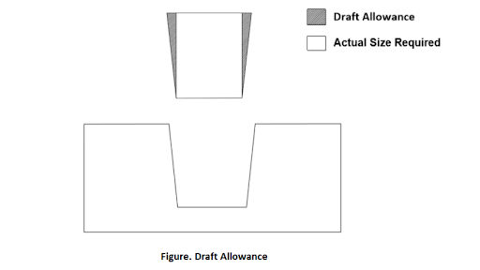
- SHAKE ALLOWANCES
- During shaking the size of the cavity will become greater than the size of the pattern.
- To avoid this problem the maintain the required size of the casting the original size of the pattern is reduced by the amount called shake allowance.
- All other allowances are increasing the size pattern but shake allowance reduces the size of the pattern therefore it is called negative allowance.
- If the pattern is made by using wax or mercury or polystyrene pattern material there is no need to provide Shake allowance.
- DISTORTION ALLOWANCES OR BENDING ALLOWANCE:
- This happened when there is major change in the heat rejection area E.g. U or V shaped component.
$$D.A.∝L/t, Where L=Length And t=Thickness$$
Properties to be possessed by pattern material are:
 | Wood | Metal | Plastic
- No or Low moisture absorption, | N | Y | Y
- Low density for easy handling of the pattern, | Y | N &Y (for some materials) | Y
- Cheaper, | Y | N | Y
- Good surface finish, | Y | Y | Y
- Easiness in fabrication. | Y | N | Y
- Wood:
Out of different woods teak wood and mahogany are used as pattern material which have least moisture absorption.
- Metal:
- Low density materials will be selected as pattern materials hence aluminium and white materials are used as pattern materials.  - For manufacturing of metal pattern double shrinkage allowance must be provided on the wooden pattern.  - The wooden patterns are used for producing few numbers of casting whereas metal patterns are used for continuous casting applications. | Density of different material are as follows:  Al = 2700 Kg/m³  White Metal = 3200 Kg/m³  Titanium = 4300 Kg/m³
- Plastic: Different plastic used are: Epoxy resins, PVC, Nylon, Cellulose, Polystyrene etc.
- Wax: Used for manufacturing of complex shape of pattern because of very high softness.
Limitation: Should not be used with green sand mould.
Application: Gold and Silver ornaments, Handicrafts, Turbine blades, Surgical instruments, bevel gears, weaving guides for radar system, Shutting eye for weaving technology etc.
- Frozen Mercury: It’s highly poisonous still it’s used as pattern material for manufacturing of all small sized casting.
Application: Mainly used for space application but not for commercial application.
MOULD AND CORE MAKING
MOULDING SAND: For making the mould, the sand is used as material.
The basic element present in the moulding sand are,
1 | Silica Sand | 75 to 80% | Provides Strength
2 | Clay | 15 to 20% | Used to as Bond Between Silica Particles
3 | Water or Sodium Silicate | 6 to 8% | To initiate bond formation between Silica sand and Clay

TYPES OF SANDS  Green Sand 1 + 2 + Water  Dry Sand 1 + 2 + Sodium Silicate  Loam Sand 50%GS/ 50%DS+50%Clay | Additives added in the sand:  - Saw Dust or Wood Powder: Porosity & Collapsibility Increases  - Coal Powder: Refractoriness Increases (Withstand high temp.)  - Starch or dextrin: Strength Increases
- POROSITY: The ability to escape air or gases through the moulding sand. E.g. Loam Sand has less porosity but provides high surface finish.
Permeability Test: Used to find porosity of the moulding sand. Porosity is indicated by permeability number.  $$permeability number=\frac{VH}{PAT} (Unitless)$$ | V = 2000 cm³ = Volume of air,  P = 10 g/ cm² = given in problem  A = Area of specimen (cm²)  H = D = 5.08 cm  T = time to except air (s)
Methods of improving the porosity property of moulding sand:

- Grain Size of Silica Particles
- Clay Percentage must be reduced
- Ramming or Controlling force: Porosity increases but Strength decreases.
- Saw dust or Wood powder
- Venting: Vent Holes are provided.

- STRENGTH: Measured by Test on UTM.
- COHESIVENESS: Ability to formation of bond in same particle is called Cohesiveness. Measured on UTM by Inter Laminar Shear Strength Test. Shear stress in the moulding sand is called Cohesiveness.
- ADHESIVENESS: Ability to formation bond between different particle is called Adhesiveness.
- REFRACTORINESS: It’s ability to withstand the high temperature without losing strength and hardness. Test is performed on UTM in temperature-controlled chamber.
- COLLAPSIBILITY: It’s ability of braking of sand specimen.
- FLOWABILITY: It’s ability of moulding sand to reach every corner. Fluidity =Flowability. Fluidity is used of liquid and Flowability is used for solid.
METHODS OF MOULD MAKING:
Hand Moulding | Machine Moulding
Ramming Force is low and non-uniform | Ramming force is high and uniform
Best for critical patterns | Critical Patterns distorted
Types of Machine Moulding:
- Jolting: Free Falling of Sand. And high Strength at bottom.
- Squeezing: Squeeze plate is used. And high Strength at Squeeze plate side.
- Jolting & Squeezing: Height > 200mm not good because in between portion has less strength.
- Sand Slinging: Throwing Sand at pattern using machine. It’s Costly method. And not useful for critical shaped components.
CORE MAKING
PROPERTIES POSSESSED BY CORE:  - Non-Metal  - Free from Moisture  - High Strength to with stand for self-weight and buoyancy forces during pouring process.  - High collapsibility  - 3&4 are contradictory properties. At a time, both can’t be satisfied by a particular material. | DRY SAND WITH MOULDING:  - Filling the dry sand into core box.  - High Pressure CO2 is supplied through small pipe.  - CO2 chemically reacts with sodium silicate and produced silica gel.  - Withdraw the pipe immediately and allow the silica gel to dry for 1 to 2 minutes so that it gives very high strength to core.  - After some time E.g. 5 Hours It becomes normal sand.
CORE PRINT: The recess or open space provided in a mould for positioning, location and supporting the core is called as core print.
- The core print is produced by providing the extensions on the pattern.
- The pattern will be divided into two pieces so that one piece of the pattern is kept in the drag box and another piece in the cope box.
- Max. load supported by the core print = 350A Newton. (Where, A=Surface Area at which core will be subjected)
- Net upward buoyance force is acting on the core.
- Net Buoyance force = Weight of molten metal displaced – Weight of Core
$$Net Buoyance force =gV\left(ρ_{m}-ρ_{c}\right)=V\left(γ_{m}-γ_{c}\right), Where, γ=Weight density,ρ=Mass denisity$$
Note: For uniform diameter vertical cylindrical core, net buoyance force is equal to zero, because there is no projected area is available for acting the buoyance force.
- Net Buoyance force = Weight of molten metal displaced due to projected volume – Total Weight of Core
$$Total Weight of Core=\frac{π}{4}ρ_{c}g\left[\left(D_{1}^{2}-D^{2}\right)H_{1}+D^{2}H\right], Weigth of M.M. Dispplaced= \frac{π}{4}ρ_{m}g\left(D_{1}^{2}-D^{2}\right)H_{1}$$
CHAPLETS:  - Unsupported load = Net Buoyance force - 350A. > 0 (Additional Support Required)  - Material of chaplet is same as casting material.  - Chaplet must be properly cleaned to avoid weak joint formation.  - Chaplet provides the directional solidification.  - To take care of supporting as well as avoiding the melting of the chaplets of every 1N of supporting load 29mm² cross-sectional area chaplets must be used. | 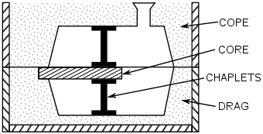  CHAPLETS used to support core material.
CHILLS:
- It’s not possible to compensate the liquid shrinkages taking place at the corner of the cavity and produces open space in the casting called as void or shrinkage cavity defect.
- Due to the provision of high thermal conductivity metal piece at the corner it’s possible to direct the heat transfer such that the solidification of molten metal is the cavity will be taking place according to our requirement called as directional solidification and the metal piece provided is called chill or chill block.
- The material used for manufacturing of chill should have melting point greater than melting point of casting material and thermal conductivity should be as high as possible.
- Based on this during casting of aluminium, copper chills are used.
 | 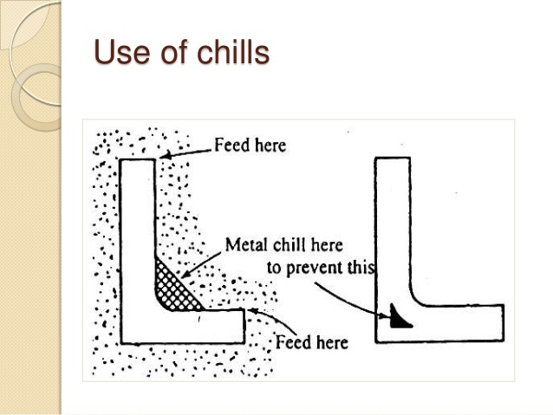
PADDING:  - During casting of sharp edges, patterns also have sharp edges.  - Whatever ramming force applied will try to slip sand particles at the corner.  - The loose sand particles present at corner will get eroded and enter into casting cavity forming sand inclusion in casting.  - To avoid above problem L-Shaped metallic pieces are kept at corner of pattern called pads.  - Basic function of pad is to avoid directional solidification as additional function. (E.g. Chills) | L-Shape Pad
POURING AND SOLIDIFICATION
POURING: Molten metal is always poured into casting cavity by using a system called as gating system.
$$Pouring time(t)= {Volume(V)}/{Flow Rate(Q)}$$
CHARACTERISTICS OF IDEAL GATING SYSTEM:
1 | Time Taken | As low as possible
2 | The velocity of molten metal | As High As possible, Laminar Flow And avoid turbulence (due to sand erosion)
3 | The flow of molten metal | Partial flow should be avoiding
4 | Impurities present | Gating system removes impurities
5 | Sand Erosion | Turbulence flow increases sand erosion and causes sand inclusion
6 | The Aspiration effect | Atmospheric air comes with molten metal and void produces called aspiration.

BASIC ELEMENTS IN THE GATING SYSTEM
POURING BASIN | SPRUE | RUNNER | INGATE
- Reservoir of molten metal  - Separates impurities (Using Skin core)  - Pouring Time doesn’t depend in the size of pouring basin. | - Placed between Pouring basin and runner.  - It’s always vertical and conical downward.  - Velocity of pouring depends on height of Sprue. And always in laminar region. | - Placed between sprue and Ingate.  - Made in Trapezoidal shape (So that we can get high Coefficient of discharge) and Discharge is high | - Helps to remove impurity using shape.

GATING RATIO = $A_{Sprue}:A_{Runner}:A_{Gate}$ | CHOCK AREA = MIN ($A_{Sprue}, A_{Runner},A_{Gate}$)
MAX. VELOCITY = $\sqrt{2gh_{Sprue}}$ | FLOW RATE = CHOCK AREA * MAX. VELOCITY

ACCESSORIES USED IN GATING SYSTEM
STRAINER | SPLASH CORE | SKIM BOB | SPRUE WALL
- Made up of ceramic material with high porosity. | - High velocity From Sprue Strikes on Splash core and erosion of sand removed.  - Made up of ceramic material with low/ no porosity. | - It’s similar to Sprue Wall but it’s feature created in the runner. | - It’s small curved portion removed from the end of sprue so that eroded sand can be trapped inside curved portion called sprue wall.

CLASSIFICATION OF GATING SYSTEM BASED ON PRESSURE ABOVE MOLTEN METAL IN POURING BASIN
NON-PRESSURIZED GATING SYSTEM | PRESSURIZED GATING SYSTEM
Pressure above molten metal is atmospheric.  It’s not useful for more reactive materials with air. E.g. Al, Zn, … | Pressure above molten metal in pouring basin is above atmospheric pressure. It’s useful for highly reactive materials with air. Here
 | Highly Reactive metals | Back Pressure gating system | Increase the velocity
 | Inert gases are used to closed chamber for pressuring the molten metal. | Same path for air to escape and Molten metal to travel in cavity. And escaped air Rises the pressure from the Pouring basin. | Giving minor pressure from the pouring basin.
Total cross-sectional area increases towards the mould cavity. | Total cross-sectional area decreases towards the mould cavity.
G.R.= 1:4:4 or 1:2:2 | G.R. = 1:2:1
Less Turbulence hence less chances of mould erosion. | More turbulence hence more chance of mould erosion.
Difficult too cast complex and thin section. | Possible to cast complex and thin section.
Casting yield is less because large metal involves in runner and gate. | Casting yield is more because less metal involved in runner and gate.

CLASSIFICATION OF GATING SYSTEM BASED ON POSITION OF INGATE IN GATING SYSTEM
Top gating system | Bottom gating system | Parting gating system | Step gating system
- Velocity of molten metal in the gating system remains constant and is equal to maximum velocity.  - Easy to make.  - Should not be used for filling cavities present in loose sand moulds.  - Maximum height of cavity up to which top gating system used is 200 mm only. | - Poring time is always higher.  - Making is difficult.  - No Sand erosion.  - Unfavourable temperature gradient.  - During casting of grey cast iron, it’s required to use only bottom gating system.  - $P.T=2 Top Gating$ | - Some part of the cavity is filled by using top gating system and some part is filled by using bottom.  - Pouring time is in between Top and bottom gating system.  - All other features gating system.  - $P.T=Top+Bottom$ | - For filling of the large cavities.  - The step gating system can be taken as: 1) Top step, 2) Bottom Step, 3) Parting Step gating system.
Assumption made in calculation of pouring time:
- Loss of energy such as loss of head due to friction, bend loss, sudden expansion losses are assumed as small and negligible.
- Time taken for filling the molten metal is the riser in assumed as small and negligible.
ASPIRATION/ INHALATION/ BREATHING EFFECT:
During the flowing of liquid through sprue, at some point the pressuring of the liquid drops from the atmospheric pressure, then the air and sand traps in the molten metal through porosity property of the gating system. And blow holes and sand inclusion defects forms. This is called the Aspiration/ inhalation/ breathing effect.
CASE-I: Straight Cylindrical Sprue | CASE-II: Parabolic Sprue | CASE-II: Conical Sprue
$$A_{2}V_{2}=A_{3}V_{3}and bournoulli^{'}s eq. between 2 and 3$$
$$P_{3}=0, h_{3}=0$$  Hence, $P_{2}=-ρgh_{2}$  So, Aspiration effect present. | $$P_{2}=P_{3}=P_{atm}=0, h_{3}=0,$$  $$R={A_{3}}/{A_{2}}={V_{2}}/{V_{3}}, V_{3}=\sqrt{2gh_{t}}$$  Hence, $R=\sqrt{{\left(h_{t}-h_{2}\right)}/{h_{t}}}$ and No Aspiration because throughout $P_{atm}$ | Due to more area than parabola the pressure is more hence there is no chance of aspiration effect.
SOLIDIFICATION
SOLIDIFICATION TIME: It’s a time taken to cool the molten metal from pouring temperature as liquid to freezing temperature as solid.
- Hear To be removed from converting liquid to solid. Hence,
$$heat removed =m\left(L.H.+S.H.\right)=Vρ\left[C_{p}\left(T_{pouring}-T_{freezing}\right)+L.H.\right]$$
- $Heat transfer through mould = \left[{KA_{s}∆T}/{\sqrt{πατ}}\right]τ$
Hence by equating 1 and 2, we get Chvrinou’s equation,
$$τ={\left[\frac{V}{A_{s}}\right]}^{2}{\left[\frac{ρ\left(C_{p}\left(T_{pouring}-T_{freezing}\right)+L.H.\right)}{K∆T}\right]}^{2}=M^{2}K,$$ | $$where. M=Mold Modulus,$$  $$K=Solidification factor or Mold Constant$$
FETTLING
Fettling: Process of braking mould and taking out casted component after complete solidification is called fettling.
Putting on vibratory mesh is good potion for fettling.
INSPECTION
Methods of detecting defects:
- Coin Testing: When the casting is hit with the coin the sound will be heard based on the sound, size and shape of defect is identified. | - Ultrasonic testing or Ultrasonic scanning:  - Through Transmission technique  - Pulse Echo technique (Experiment we did in the lab) | - X-Ray radiography: By passing X-Ray through the casting the radiography film is obtained. Based on colour variation in the radiography film it is possible to identify the presence, Size and location of defect.
RISER DESIGN
Riser acts as reservoir for supplying molten metal to the casting cavity for compensating liquid shrinkage taking place during solidification.
CONDITION 1 | CONDITION 2 | CONDITION 3 | CONDITION 4
Riser Volume fine experimentally,  But practically $V_{riser}≥3V_{Shrink}$ | Solidification time | Location of riser | Shape of riser
 | $$τ_{riser}>τ_{Casting}$$ | - Uniform c/s Component: Riser placed at the top of casting.  - Non- Uniform c/s Component: Riser placed near thickest portion. | Cylindrical, Spherical, Cubical, Rectangular.  Select Minimum Surface area for minimum heat transfer. Hence, heat transfer ratio = $Q_{Cube}:Q_{Cyl}:Q_{Sphere}$ = 1: 0.439: 0.71
For cylindrical riser, there is 2 types:
Top Riser | Side Riser
For minimum heat transfer Surface area in cylindrical riser, D = 2h. | For minimum heat transfer Surface area in cylindrical riser, D = h.

Modulus related to solidification of riser (M_{r} = $V/{A_{s}}$)
Spherical Riser | Top Cylindrical Riser | Side Cylindrical riser
M_{r} = D/6 | M_{r} = D/6 | M_{r} = D/6

DESIGN OF THIN PLATE
For n Riser | Single Riser | Two Riser
- $L =4t n$  - $L=4t n+5t$  - $L=4t n+5t+100mm$  - $L=\left(9t+100\right)n$ | - Without End wall effect: $L =4t$  - With End wall effect: $L =9t$  - With End Chills: $9t+100mm$ | - Without End wall effect: $L =8t$  - With End wall effect: $L =13t$  - With End Chills: $13t+100mm$  - With End and central chills:  $$18t+200mm$$
SPECIAL CASTING PROCESS
Slush Casting | Shell Mould Casting | Investment Casting | Centrifugal Casting | Die Casting
- SLUSH CASTING:
Applications: Used for producing decorative parts like lamp shades, Christmas trees, Hollow statues etc.
Here, $τ=M^{2}K∝M^{2}∝{(V/{A_{s}})}^{2}∝t^{2}$, And hence, $t_{i}=C_{1}\sqrt{τ_{i}}+C_{2}$,
Where, $C_{2}$=Instantaneous Solid/ Skin Formation. If mould is heated up to liquid temperature, then $C_{2}=0$.
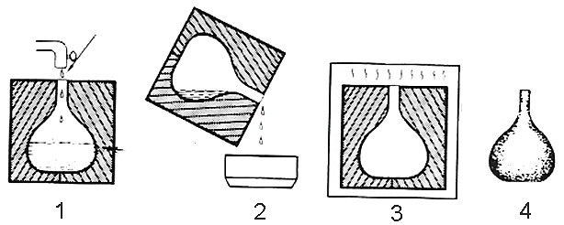  Slush Casting | 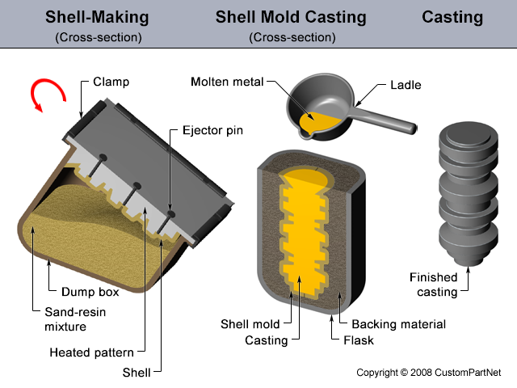  Shell Mould Casting
- SHELL MOULD CASTING:
- Take the metal pattern.  - Dip the metal pattern in Phenolic Resign ($μ$ = 1500 to 2500 cP) (Thermosetting plastic – Can’t reheated and reformed) for 1 to 2 min.  - Keep it in a furnace at 270 $°$C to 300 $°$C for 1 to 2 min. Phenolic resign will convert into solid.  - Remove top layer of phenolic resin.  - Take out the pattern and remaining phenolic resign material called mould.  - With above standard procedure the thickness of mould obtained only about 6 to 10 mm.  - By varying the heating time, the required thickness of phenolic resign mould will be obtained.  - To increase the strength of phenolic, resign mould, small quantities of silica particles will be added to it.  - If ceramic slurry is used as mould material, then it’s called as ceramic moulding operation. | Feature:  - Mould weigh is less.  - Production rate of mould is high.  - Mould making can be mechanised or automated.  - Surface finish is high.  - Low Porosity property.  - Phenolic resign is not a reusable material.  Applications: Circular and symmetrical shaped job such as cylinder and cylinder head of IC engine, Engine Valves, Gear Blanks, Crankshaft, Etc….
- INVESTMENT CASTING/ LOST-WAX PROCESS:
- Invest: To cover (1 cover over pattern)  - Name: Wax is Lost by heating.  - Pattern material: Wax and mould material: RCC  - It’s also called as semi-permanent mould casting process.  - Surface finish is high.  - Porosity is obtained by making vent holes, because RCC is not porous.  - Thermal Conductivity of mould material is high. | Steps in investment casting:  - Wax patterns are produced by injecting the wax into the die.  - Several wax patterns are attached to sprue to form pattern tree.  - The pattern tree is coated with slurry of refractory materials.  - The full mould is formed by covering the pattern tree with STUCCO (DRY SAND) to make it rigid.  - The mould is held in an invert position and heated then liquid wax leaves the cavity.  - Pour the molten metal into the mould and allow it to solidify.  - After Solidification the casted component can be taken out by breaking mould.  - Finally separate the parts from the sprue.
Application: Used for producing complex shapes of the components of smaller size such as gold and silver ornaments, turbine blades, surgical instruments, handicrafts, bevel gears, wave guides for radar system, shuttle eye for weaving, denture (Artificial teeth) etc…
INVESTMENT CASTING 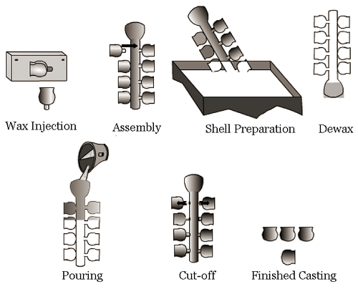 | CENTRIFUGAL CASTING  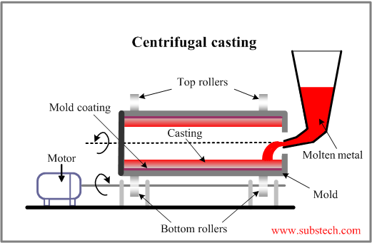
- CENTRIFUGAL CASTING: The centrifugal force produced due to rotation of mould will be used for distributing the molten metal around the circumference of the mould. The rotation of the mould is continued until the molten metal will get solidify and after solidification, the casting will be taken out.
- Moulds are made of steel, iron, graphite and may be coated with a refractory lining or sand lined to increase mould life.
- This method is mainly developed for producing large size hollow casting without the use of core.
- For producing casting, acceleration of the mould required in around 65g to 75g.
- Centrifugal force. $F∝ρ$
- Centrifugal force acting onto the low-density impurities will be lower.
- Centrifugal casted component will have machinability. This is because segregation or separation.
- During casing of alloys different metals have different densities. Therefore, centrifugal force acting will be different and the molecules of different elements are trying to separate.
- Before they are going to separate the molten metal solidifies and produces layered structure. i.e. forming heterogenous material. Hence, the mechanical properties are varying and machinability becomes poor.
- If axis of rotation and axis of mould are coinciding then it’s called as true centrifugal casing.
- If axis of rotation and axis of mould are not coinciding then it’s called as eccentric or semi-centrifugal casing.
Application: For producing large size hollow casting without the use of core. E.g. Pully.
NOTE: It’s not possible to use the vertical axis of rotation because the acceleration of mould required is very high which about 1500g to 200g.
- DIE CASTING/ PERMEANT MOULD CASTING:
- Metals that can be used as mould are: Tool Steel, Die Steel, Tungsten carbide etc.
- Used for producing the casting with low melting point temperature materials like lead, Tin, aluminium etc.
- The silicon powder (Lubricants) will be sprinkled on the mould surface before pouring the molten metal.
- Porosity property of metal mould is zero, venting holes must be provided.
- The die is cooled by water for efficient cooling of casting. This also increase die life.
- It gives high surface finish hence machining may avoid.
Die Casting process divided into:
HOT CHAMBER DIE CASTING | COLD CHAMBER DIE CASTING
Into the heated mould, powdered from of casting material will be filled. | The liquid molten metal of casting material is filled into the room temperature mould.
Used for casting of very low melting point metals such as lead, tin, zinc, cadmium etc. | Cold chamber die casting is further divided into: 1) Gravity die casting, 2) Pressure die casting. It used for all type of materials.
GRAVITY DIE CASTING |  | PRESSURE DIE CASTING
- Flow of molten metal into the casting cavity is due to gravitational force.  - This method is used for producing the simple shapes of the casting such as the aluminium alloy piston of IC engine. |  | - Flow of molten metal into the casting cavity is taking place due to the application of external pressure. It is similar to the injection moulding in case of plastic.  - Due to the application of external pressure, it is possible to flow the molten metal into each and every corner of the complex shape of the cavity.  - Used for producing complex shapes of the casting such as carburettor of the IC engine made by an aluminium alloy.
Expandable Mould (Temporary Mould) |  |  | Permanent Mould (Metallic Mould)
Used only for one Component casting |  |  | Used for more than one Component casting
Sand, Shell, Ceramic, Investment |  |  | Slush, Centrifugal, Die
DEFECTS IN CASTINGS
- Blow or Blow Holes: The air or gas bubble present inside the casting.  REASONS: 1) Low porosity property of moulding sand. 2) Presence of aspiration effect in the gating system. 3) Allowing partial flow of molten metal in the gating system.  - Scar: The air or gas bubble present near to the surface of casting.  - Blister: The air or gas bubble present near to the surface of casting.  - Porosity: The air or gas particles present in the casting.  - Misrun: Non-filling of projected cavity with molten metal.  - Dross: Impurities or foreign particles present inside the casting.  - Sand Inclusion: Sand Particles present in the casting.  - Void or Shrinkage Cavity: The Open space produced inside the cavity. | - Rat Tail: Tail like elements produced on a surface of the casting is called as rat tail defect. It’s produced when wax pattern is used with green sand.  - Shift: The mismatch present between the cavities of cope and drag produces the step in the casting called as the shift defect.  - Cold Shut: The discontinuity produced due to hindered contraction in casting.

